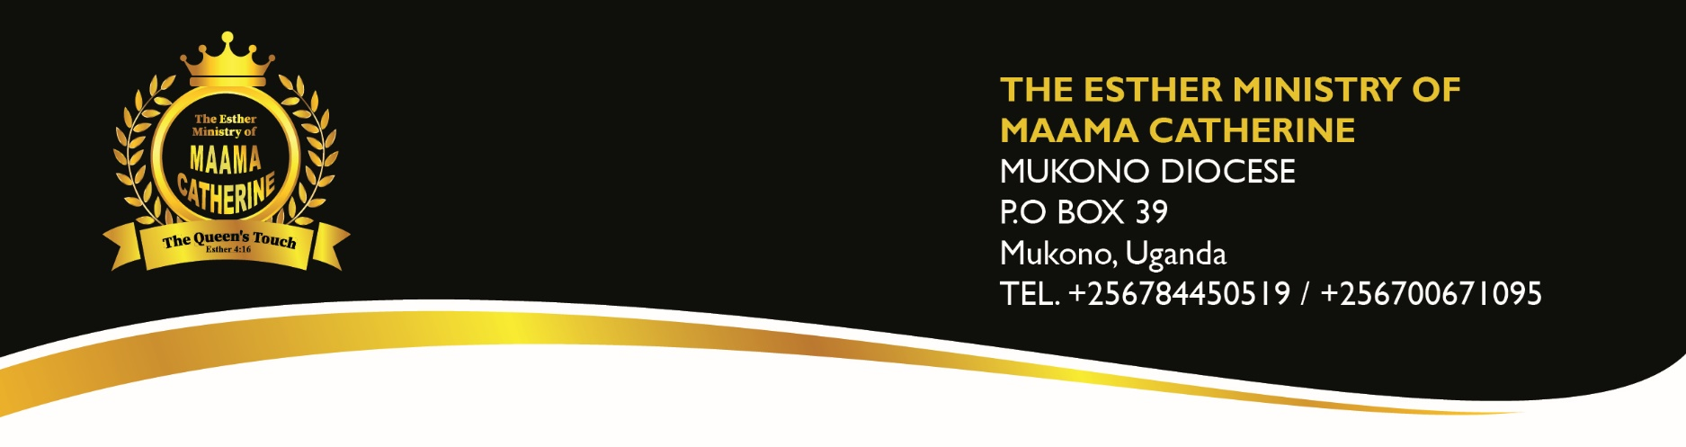

ORGANIZATION PROFILE
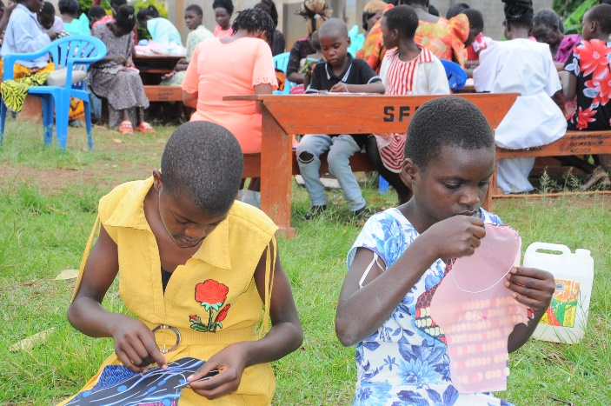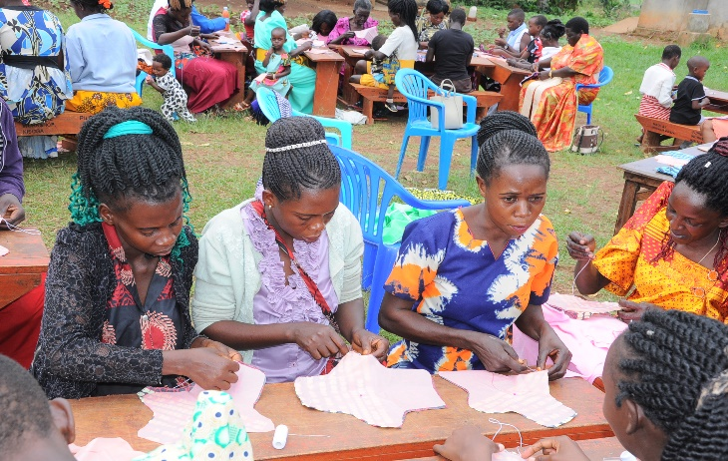
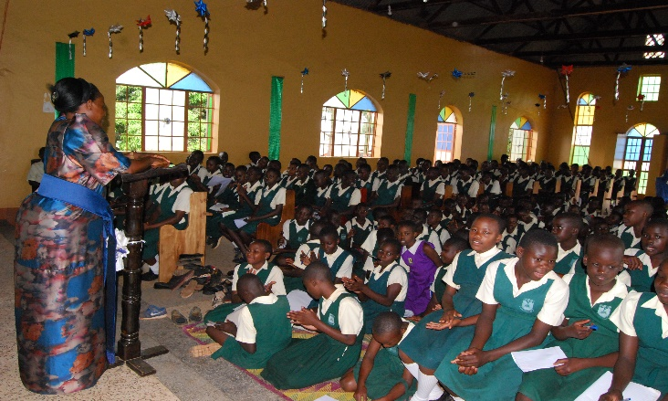

ORGANISATIONAL OVERVIEW
The Esther Ministry of Maama Catherine is a community Based organisation regulated by Mukono Diocese with its head office at Mukono Diocese. The organisation was established in 2023 mainly to operates as a Ministry offering relief, rescue and hope restoration to individuals and communities that have been affected by various disasters and problems like Covid 19, Gender Based Violence, drought, famine and many other arising issues.

The main objective of this organisation is to win souls on behalf of the Kingdom of God through charitable deeds and restore hope, peace and unity amongst targeted beneficiaries of Mukono Diocese. We believe that we can still spread a gospel of actions to encourage people out there because we believe there is a high need.
The organisation has a thorough understanding of project work and technical requirements for successful project implementation, knowledge of which is utilized to the benefit of our beneficiaries.

The Esther Ministry of Maama Catherine aims at gathering all able Christian to rescue the unable ones through various was of tangible and intangible support. We basically bridge the gap between the needy and the potential helpers. The organisation provides customized interventions through various communities to empower them accordingly. To ensure that this level of quality is maintained, the organisation possesses staff comprising of technical and management specialists.

The beneficiaries of the Esther Ministry of Maama Catherine include the following;
- Children (Child Abuse Cases)
- Youth
- Young Mothers(Victims and Survivors of Gender Based Violence)
- The Elderly
- The Widows
- The Disabled

Over the past one year, The Esther Ministry has undertaken several interventions in different parts of Mukono diocese as a way of giving hope to beneficiaries for example school ministry intervention around various schools making distributions of scholarstic materials for students, Charity interventions amongst young mothers, prisoners, the elderly and the disable children, WASH interventions specifically various trainings on Re usable Pad making, re-usable pampers, Counselling sessions as well as referral cases over Gender based Violence, rape and Defilement. We have completed several high profile projects on behalf of Mukono Diocese like skilling of Young mothers and the elderly to eradicate poverty and also an escape route for survivors of Gender Based Violence.

The Esther Ministry of Maama Catherine currently holds a work force of forty five (45) financial, administrative and field staff. Our technical staff is well trained and equipped to provide high standard workmanship and to cope with the challenges posed by each project we undertake.

The Esther Ministry of Maama Catherine prides itself in conducting all its activities to conform to the standards set Mukono Diocese

  - LEGAL STATUS
The Esther Ministry of Maama Catherine is registered as a community Based Organisation.
  - GENERAL ADDRESS
Mukono Diocese
P.O. Box 39, Kampala - Uganda
Tel.: 0706360045/0784450519
Email: emmcministry2023@gmail.com

  - WHAT WE DO
- Skills Training for children, youth and elderly
- Charity work interventions
- Counselling & Referrals
- Back to school campaigns
- Medical campaigns
- Prayer gatherings
- Marriage conferences
- Social gatherings

  - NAMES AND ADDRESSES OF DIRECTORS

Maama Catherine Kitto
Founder
P.O. Box 39, Mukono Uganda

Martha Owora
Finance and Administration Officer
P.O. Box 39, Kampala

Note: The Rt. Enos Kitto Kagodo, Bishop of Mukono Diocese is the over seer of this Ministry giving him all rights to make decisions on behalf of the Ministry

1.5 BANKERS
EQUITY BANK UGANDA

  - VISION
A survivor based mission regulated by Mukono Diocese aimed at gathering all able Christians to rescue communities that are needy through charitable deeds both spiritually, physically, emotionally and financially.

1.7 MISSION:
The desire to make a sustainable Christian Community that thrives in spiritual, social, and economical values.

1.8 OBJECTIVES
- To win souls on behalf of the Kingdom of God through charitable deeds.
- To restore hope, peace and unity amongst targeted beneficiaries of Mukono Diocese
- To rehabilitate victims and survivors of Gender based Violence through referrals, counselling services
- To feed communities that have been hit by natural calamities like hunger, drought
- To sensitize communities on their ways of living through social gatherings and social media platforms
- To ensure self employment opportunities amongst young adults to eradicate poverty in communities of Mukono Diocese

1.9 EMMC SLOGAN & SPIRITAL VALUES:
“The Queen’s Touch”

1.9.1: Spiritual Values
- Compassion
- Hospitality
- Patience
- Tolerance and Acceptance

- FACILITIES, STAFF AND EQUIPMENT

  - FACILITIES AVAILABLE

- Administrative & Projects Offices at Mukono Diocese

  - ADMINISTRATIVE AND TECHNICAL STAFF

Item | Description | No.
1 | Founder | 1.
2 | Administrative Staff
 | Finance and Administration Officer | 1
 | Program Coordinators | 2
 | Project Officers | 2
3 | Technical Personnel
 | Field Officers | 3
 | Lay Readers Wives | 12
 | Field Officers | 12
 | Enumerators | 12
TOTAL NO. OF STAFF |  | 45

ORGANISATION STRUCTURE OF THE ESTHER MINISTRY OF MAAMA CATHERINE

THE BISHOP

THE BOARD

VOLUNTEERS
FOUNDER
ENUMERATORS
LAY READERS WIVES
FIELD OFFICERS
FIELD ASSISTANTS
PROGRAM CORDINATORS
FINANCE AND ADMINISTRATION
PROJECT OFFICERS

